HW 10 – Maximo Antigua

Part 1

Add a screenshot of the jproject01-01.html after completing Step 6

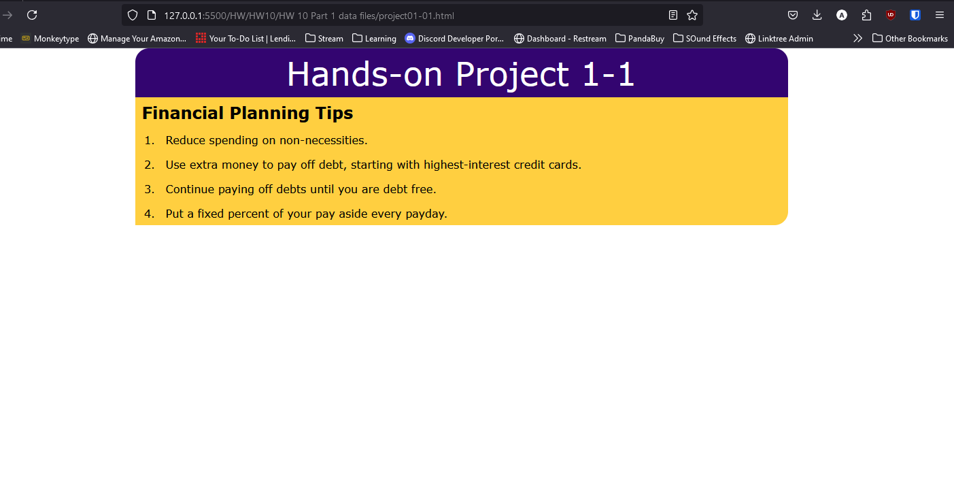

Part 2

Add a screenshot of the jproject01-02.html after completing Step 7

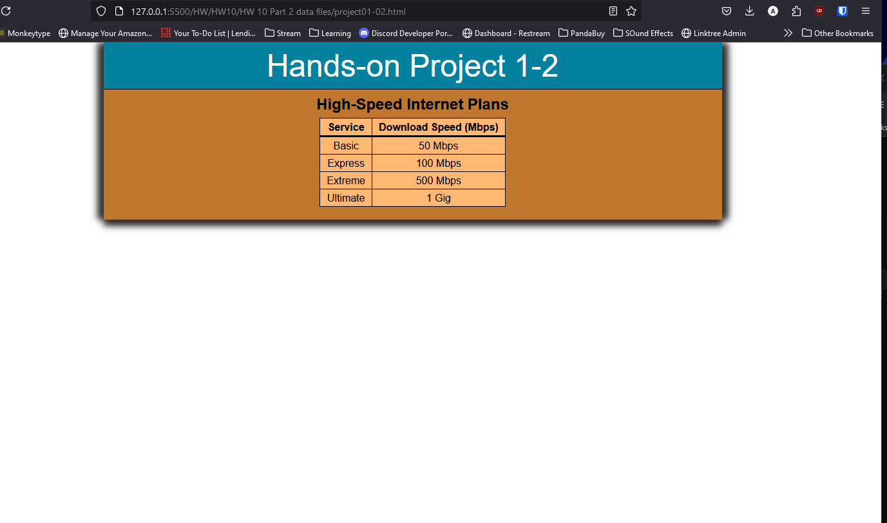

Refer to Chapter 1

List 4 things you have learned about JavaScript after Completing Lab 10.1 , Lab 10.2 and HW 10

Item 1

That there is no need to compile JavaScript since it’s not a programing language but a scripting language

Item 2

That there are multiple ways to create variable (let, var, const)

Item 3

Learned more about an event handler, its usage and how to create one.

Item 4

Understanding that leaving comments is the same as in HTML.